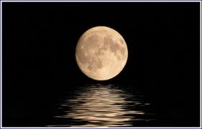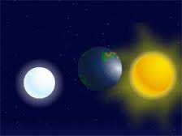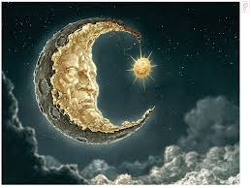**The Moon & the Sun**(Little Story)

Once there lived three friends. One friend is Moon second friend the Sun and third friend Earth. One day the sun and the moon were arguing. The moon feels that he is a great person because of him everyone sleeping happily. People always wait for him. The Sun tells Moon that hands that serve are holier than lips that pray. Thoughtless words can wound as deeply as any sword but wisely spoken words can heal. You may think that everything you do is right, but remember that the lord judges your motives.

We explore the stars and the depths of the sea, but how much do we know about ourselves and the reason for being here. Always do your duty and leave the result to God. But I also think positive. I, you and Earth are very important to the world. I am also important because 0f me the day is coming and people are doing there works in the daytime but I don’t feel proud.

Earth is also important and it wont feels proud the world always lives in the Earth. Earth gives space for everyone, for big cheats, stingy persons, brainless mans, thieves, misers and crooks etc,. It excuses everyone. If you oppress poor people, you insult the god who made them; but kindness shown to the poor is an act of worship.

The Sun tells moon that a lie has a short life, but truth lives on forever.

The moon tells everyone that I am sorry friends. I don’t know everyone’s life is important but my life is. I understood that this world revolves around sun, moon and earth. Contentment is the best of riches. It is easy to find fault with others but not so easy to see one’s own fault. Ok friend cool down we are not feeling with your words as one’s fault is another man’s lesson. Our greatest glory lies in never falling but in rising every occasion we fall. It takes twenty years to build a reputation and five minutes to run it. This story speaks about three good friends and importance. Everyone is important in this world as everyone came to this world to do something and everyone has their own talent. The moon, the sun and the earth have their own importance one is always better than the other.

